Newsletter
Issue 8 Term 2 Week 6

TERM 2
Week 7

Mon 10/6
Public Holiday
Queen’s Birthday

Wed 12/6
Camp Quality
Puppet Show

Week 8

Mon 17/6
School Photos

Author/Illustrator
Incursion

Wed 19/6
Governing Council meeting 2:00pm

Week 9

Tues 25/6
Special lunch

Thurs 27/6
Music is Fun Incursion

Fri 28/6
Korfball SAPSASA

Week 10

Fri 5/7
Last Day of School
Early Dismissal
2:05

A Message from the Principal
Grandparents and Special Friends Day
What a fantastic Grandparents and Special Friends Day we had last Thursday. It was wonderful walking around the school visiting classes and seeing how engaged our visitors and students were. Many thanks to Anne T for all her hard work organising this special annual event. A big thanks, also to staff for designing activities and tasks and planning and practicing concert items. Thanks also to staff who helped set up and pack up on the day. Furthermore, many thanks to Julie for organising the special lunch menu and to Anne B and Lyn for all their hard work helping Julie in the canteen. It was lovely hearing positive feedback from grandparents, special friends, parents and family members who attended this event!

Pupil Free Day focus – Moderation and Learning Design
During our Pupil Free Day on May 27th, teaching staff engaged in professional development focusing on moderation. Many thanks to Natalie and Simon for their hard work organising and planning this day and ensuring it targeted our staff and student needs.

Collaborative moderation aims to build consistency and confidence in teacher judgement as the first step, enabling A-E grades to be used as valid and reliable data for school improvement processes. This then enables teachers the opportunity to critically reflect on the initial learning design to ensure high expectations, engagement and achievement can be realised for every learner. On our pupil free day it was highly beneficial for staff to have time in professional learning communities to engage in moderation of student work, clarify information and discuss learning design. We look forward to sharing more about our moderation focus in the future.
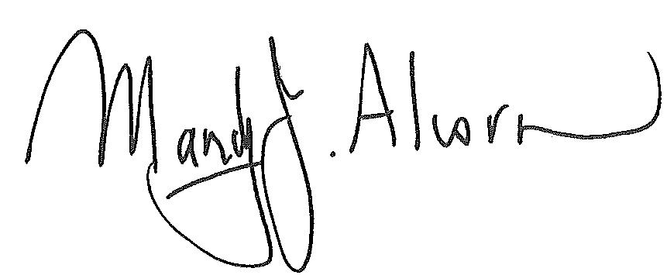
Principal

Regards,
Mandy Alcorn - Principal

Diary Dates

Diary Dates

“Effective collaboration involves more than simply working together. It demands a disciplined and purposeful approach to collaborating to solve the challenges that are most important to improving student outcomes.”

Australian Institute for Teaching and School Leadership 2012

Bradman Road, Parafield Gardens SA 5107 Phone 08 82583612 Fax 08 82815851 Email dl.1135.info@schools.sa.edu.au www.karrendips.sa.edu.au

Room 24
World Environment Day

On Wednesday 5th June, Room 24 celebrated World Environment Day. We looked at the area in front of our classroom and noticed the amount of rubbish littered across the path and playground. We talked and learned about how litter negatively affects our environment and especially native wildlife. We decided to go out into the yard and collect all the rubbish. When we came back to the classroom, we thought about how we could encourage other students to pick up their rubbish and put it in the bin. We decided to make posters with words and pictures that will encourage students to put their rubbish in the bin. We brainstormed the words and pictures that would show students why they should put rubbish in the bin and how to put rubbish in the bin as well.
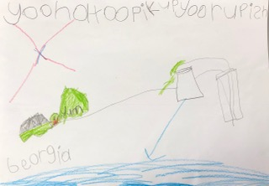
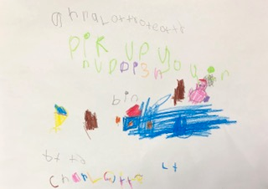
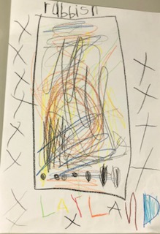
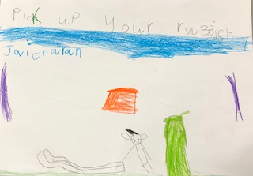
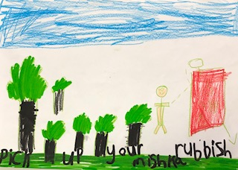
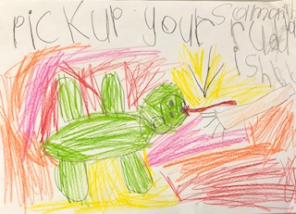
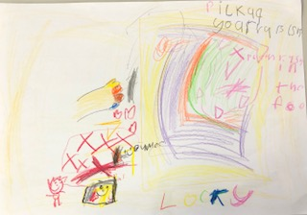
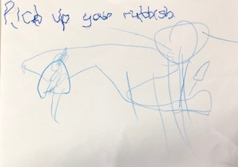
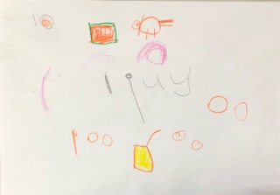

Grandparents and Special Friends Day
What a fantastic Grandparents and Special Friends Day we had! Thank you to the many families and friends who came along. It was great to see students so excited to show their special guests around the school and spend time in their classrooms doing fun and engaging activities. Here are some happy snaps from the day!
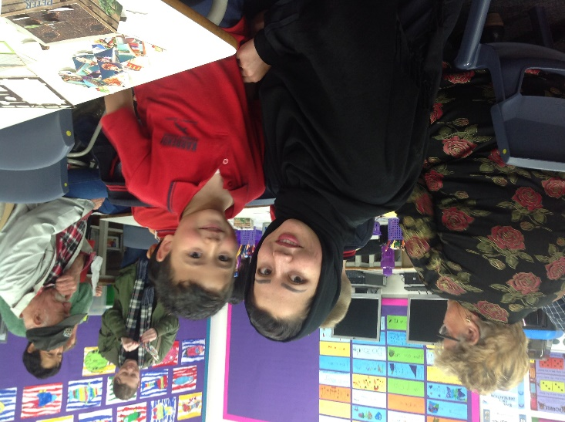
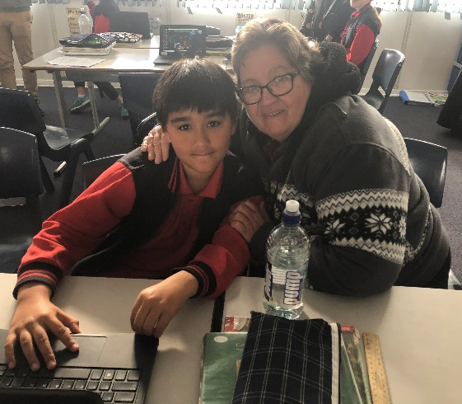
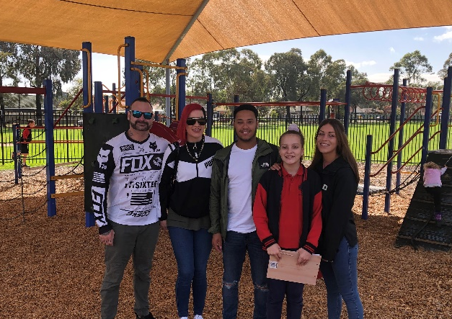
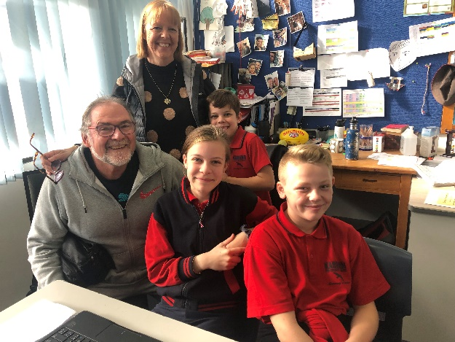
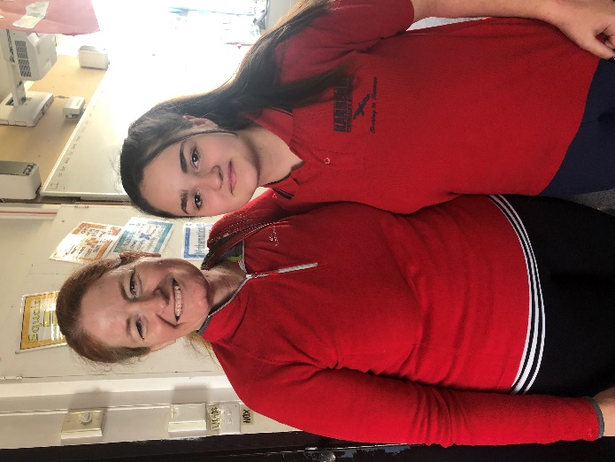
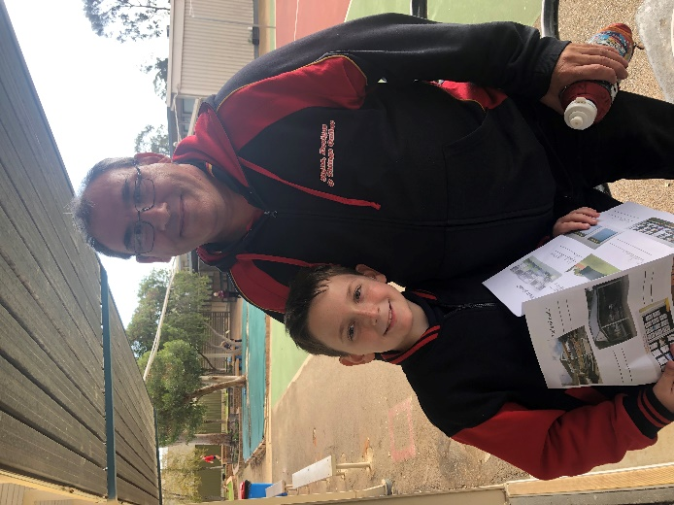
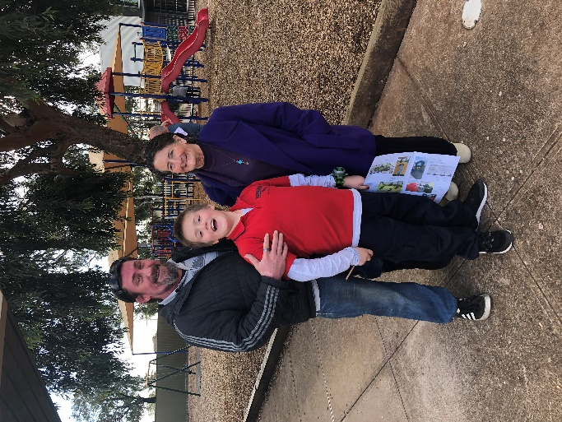
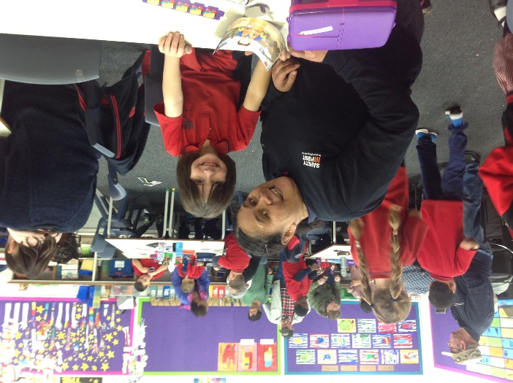
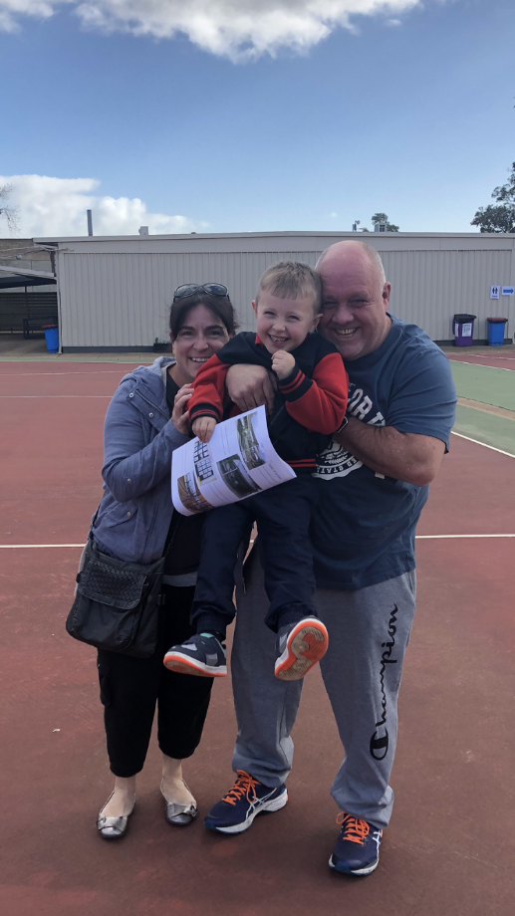
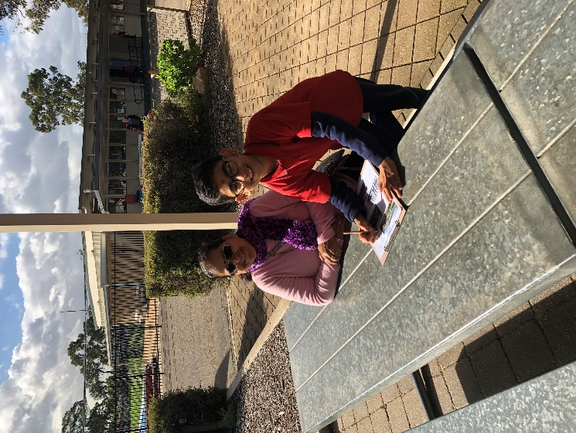

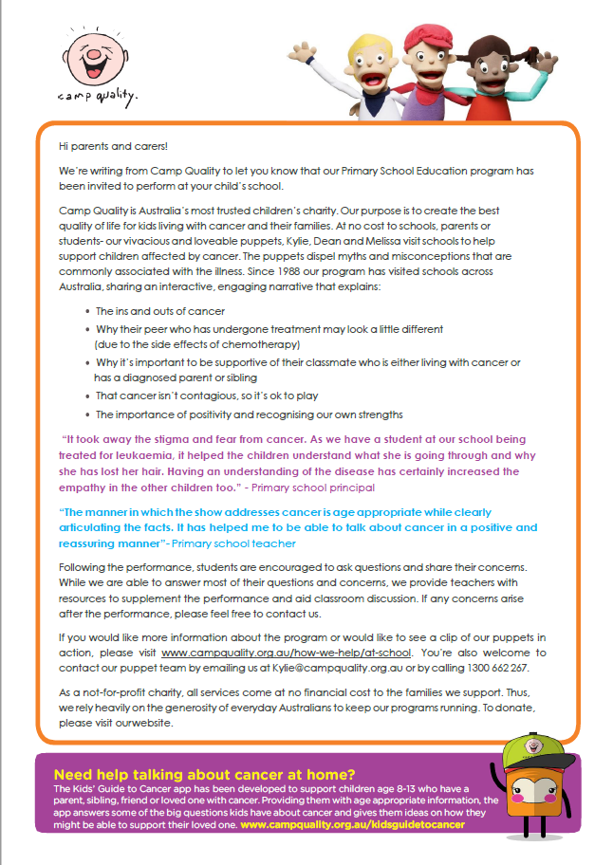
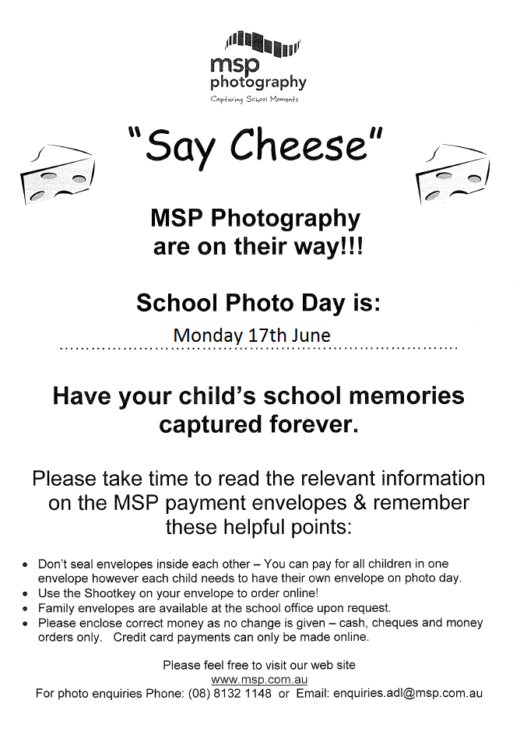
Author Visit – Dr Cameron Stelzer, The Story Doctor
On Monday 17 June, we have a special visit from Author and Illustrator Dr Cameron Stelzer. Dr Cameron is visiting Karrendi Primary School to run workshops with our students. R-3 students will enjoy an interactive Big Screen Book Reading and follow-along drawing activity / inspirational ideas writing session with Cameron. Year 3-7 students will be taking a behind-the-scenes look at creating a book, and applying their own creative components. Students and teachers are looking forward to a great day!
In conjunction with the Author Visit, Karrendi PS families have a special opportunity to purchase signed and personalised copies of Cameron’s books at special prices. Individual books are $15 each and there are also exclusive book sets available. Students will receive an order form on the day of the workshops. Forms and payment can be returned the following day, Tuesday 18 June, to the Front Office.

